OpenCDS Developer Workstation Configuration Instructions

Last updated July 21, 2011

- Document Version History
  - 10/3/2010
    - Initial creation by Kensaku Kawamoto, based on source documentation created by David Shields
      - Eclipse Configuration for OpenCds.doc
      - Installing Drools on Tomcat.docx
      - Installing JBoss Drools Plugin for Eclipse.docx
  - 4/22/2011
    - Major update by David Shields
      - Updates included successful upgrade to Maven version 3, updating of repository references and images, and use of OpenCDSAlpha SVN repository. Verified instructions through a fresh install on a Windows XP machine.
  - 4/25/2011
    - Updated by Kensaku Kawamoto
      - Verified instructions through fresh installs on two separate Windows Vista machines; made miscellaneous updates.
  - 5/9/2011
    - Updated by Kensaku Kawamoto
      - Updated download URL for Apache CXF
  - 5/15/2011
    - Updated by Kensaku Kawamoto
      - Updated instructions to more strongly note that the OpenCDS alpha release should be imported into a new Eclipse instance. Also noting that OpenCDS should be installed into a new Eclipse workspace.
  - 5/15/2011
    - Updated by David Shields
      - Added comments to instructions for installing SpringSource.packages
  - 7/21/2011
    - Updated by David Shields
      - Added notes about 64-bit Eclipse, and expanded troubleshooting section

Table of Contents

I. Installation and Setup of Infrastructure Components 3
A. Install Java 3
B. Install Maven 3
C. Install Apache CXF 4
D. Install Tortoise SVN 4
E. Install Tomcat 6 4
F. Install latest stable version of Eclipse 5
G. Install Eclipse plugins 6
II. OpenCDS Configuration in Eclipse 16
A. Download and install Drools 5.1.1 jars into local Maven repository 17
B. Download and install Spring Source jar into local Maven Repository 17
C. Apelon Configuration in Eclipse 18
D. Import Projects into Eclipse 18
E. Build OpenCDS Eclipse Project 24
F. Troubleshooting 25
1. Check the results of the Maven Installs 25
2. The nuclear option 26
III. Drools Guvnor Configuration 27

Note: These instructions have been verified via fresh installations onto a Windows XP 32-bit machine two Windows Vista 32-bit machines, and a Windows 7 64-bit machine. If you have Windows User Access Control turned on, you may need to disable it in order to complete the installation properly.

We also have reports that OpenCDS has been successfully installed on Linux and Macintosh machines, by users who are experts in those environments.

Also note: these instructions do not encompass setting up an Apelon DTS terminology service instance. Setting up such an instance is not required for use of OpenCDS. Documentation on setting up an Apelon DTS instance can be found at http://apelon-dts.sourceforge.net/. Of note, we would like to explore creating a common Apelon DTS instance for use by the OpenCDS community.

Installation and Setup of Infrastructure Components

Install Java
- Install Java SE SDK version 6 or above
  - For these instructions, downloaded SE SDK 6 Update 25 from http://www.oracle.com/technetwork/java/javase/downloads/index.html, as jdk-6u25-windows-i586.exe (we generally suggest that you use the latest update of Java SE SDK 6)
  - Run executable, install using default options
    - Default installation directory for JRE is C:\Program Files\Java\jre6, which also creates a directory for the SDK at C:\Program Files\Java\jdk1.6.0_25; use of these directories are assumed in the directions below. There is no reason not to use a different location if you know what you are doing.

Install Maven
- Download .zip file of latest stable Maven build from http://maven.apache.org/download.html
  - These instructions have been tested for both Maven 3.0.3 at http://www.apache.org/dyn/closer.cgi/maven/binaries/apache-maven-3.0.3-bin.zip and Maven version 2.2.1 at http://www.apache.org/dyn/closer.cgi/maven/binaries/apache-maven-2.2.1-bin.zip
  - NOTE: there are significant differences between Maven 3.x and Maven 2.x, and we have not used Maven 3 extensively yet. However, we have conducted initial testing and have reviewed the Maven 3.x documentation. Based on this research, we have concluded that Maven 3.x should work with the current code base, which was developed primarily using Maven 2.x. Therefore, directions below are for Maven 3.0.3.
  - Unzip archive
  - Follow instructions in README.txt, provided below
  - Directory specifications below are not mandatory, but recommended for consistency purposes
    - Place unzipped folder (apache-maven-3.0.3) in following directory: C:\Program Files\Apache Software Foundation
  - Control Panel → System → Advanced → Environment Variables → System Variables
    - Set MAVEN_HOME to “C:\Program Files\Apache Software Foundation\apache-maven-3.0.3”
    - Add %MAVEN_HOME%\bin to Path
      - In this example, was added to beginning of Path
    - Set JAVA_HOME to Java SE SDK location
      - E.g., C:\Program Files\Java\jdk1.6.0_25
  - Test it by typing into a command prompt mvn --version (note there are two dashes before “version”) and it should show something similar to this:
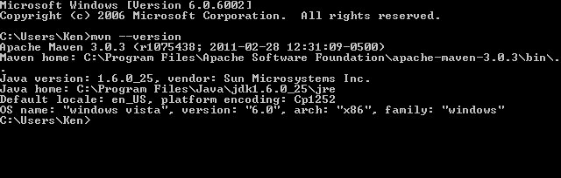

Install Apache CXF
- Download binary version 2.3.3 from http://cxf.apache.org/download.html, at http://archive.apache.org/dist/cxf/2.3.3/apache-cxf-2.3.3.zip
- Unzip and move the apache-cxf-2.3.3 folder to C:\Program Files\Apache Software Foundation\apache-cxf-2.3.3

Install Tortoise SVN
- Download from http://tortoisesvn.net/downloads.html
- Version used for this example is 1.6.15, Build 21042 - 32 Bit
- Install using default options
- Restart machine

Install Tomcat 6
- Download “32-bit/64-bit Windows Service Installer” from http://tomcat.apache.org/download-60.cgi
  - These instructions use Tomcat version 6.0.32
- Accept defaults
  - We install it at default location of “C:\Program Files\Apache Software Foundation\Tomcat 6.0” to be compatible with other Duke uses of Tomcat, many of which have hard-coded paths to that location.
- Set Tomcat Administrator Login to something secure
- Control Panel → System → Advanced → Environment Variables → System Variables
  - Set CATALINA_HOME to, e.g., “C:\Program Files\Apache Software Foundation\Tomcat 6.0”
  - Add %CATALINA_HOME%\bin to Path
    - In this example, was added to beginning of Path

Install latest stable version of Eclipse
- From http://www.eclipse.org/downloads/
  - In this example, installed Eclipse Helios version 3.6.2
- Select 32 or 64-bit version.
  - If you install the 64-bit edition of Eclipse, then you will probably need to install a helper file, available from Slik Subversion, to allow Eclipse and its various plugins to pay nice with the 64-bit Windows OS
    - http://www.sliksvn.com/en/download
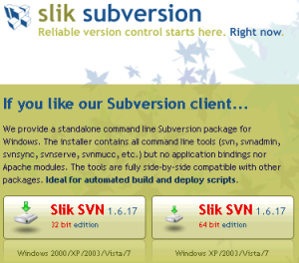
    - Download the 64-bit Windows Edition
    - It is a one-click install
    - You will also probably need to reboot after the install
- Create an Eclipse instance by unzipping the zip archive into a directory of choice
  - NOTE: if you already have eclipse installed (e.g., at C:\Program Files\eclipse), we strongly recommend that you install eclipse in a different directory (e.g., C:\Program Files\eclipseOpenCDS). This way, you will not impact any existing code or Eclipse settings (e.g., with regard to plugins). Furthermore, in the event that you need to uninstall and reinstall OpenCDS, you will be able to delete the OpenCDS eclipse folder without impacting any other projects.
  - The default directory used for these instructions is C:\Program Files\eclipse, which is where the Eclipse instance will be created if you unzip the zip archive directly into C:\Program Files
- Notes
  - You do not need to modify your path or add environment variables to use eclipse
  - Read the release notes (especially if you have problems) found at C:\Program Files\eclipse\readme\readme_eclipse.html
  - Remember that you can often fix weird problems in eclipse from a command prompt by running “eclipse –clean” which will start eclipse with a clean slate
- Create shortcut for Eclipse that passes in Java Virtual Machine parameters that a) ensures that the JDK is used rather than the JRE and b) ensures sufficient memory is allocated. Then, use the shortcut for launching Eclipse. Different shortcuts can be created if different Eclipse configurations are desired.
  - E.g., edit target of shortcut to:
"C:\Program Files\eclipse\eclipse.exe" -vm "C:\Program Files\Java\jdk1.6.0_25\bin" -vmargs -Xmx900m
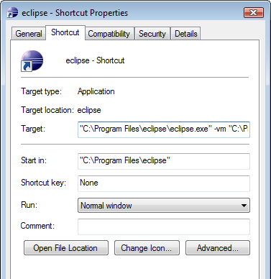
  - Alternatively, the C:\Program Files\eclipse\eclipse.ini can be edited.
    - For more information, see http://wiki.eclipse.org/FAQ_How_do_I_increase_the_heap_size_available_to_Eclipse%3F, http://wiki.eclipse.org/Eclipse.ini.

- When first starting Eclipse, set workspace to appropriate directory
  - Suggested location is “C:\OpenCDS”
  - NOTE: the current OpenCDS alpha release in the OpenCDS SVN includes settings information regarding the workspace. We strongly recommend that you do not place OpenCDS in an existing Eclipse workspace, as this may over-write existing settings in that workspace.

Install Eclipse plugins
Eclipse has built-in tools to locate and install plug-ins, and to update them when necessary. Use the built-in tools whenever possible.

There are two ways to do this. The new method is called Eclipse Marketplace. Use it whenever you can by going to
Help → Eclipse Marketplace
The traditional method is more tedious, and will need to be used if you can’t find the software you are looking for in the Eclipse Marketplace. It is also used for some plugins that don’t install all the required options when run from the Marketplace menu. This method is used by going to
Help → Install New Software

  - Install M2Eclipse
    - Before you can use Maven from Eclipse, you will need to make sure that you are running Eclipse from the JRE that is part of a JDK virtual machine. One safe way to do this is to create a shortcut for running Eclipse, and adding the path to the JDK in the shortcut target, as described above under the Eclipse installation instructions.
    - From Eclipse Marketplace – DO NOT DO THIS! You will need to do the initial install the traditional way, as described next (the Eclipse Marketplace does not currently allow you to do a base install of m2eclipse)…
    - From Install New Software
      - Help → Install New Software
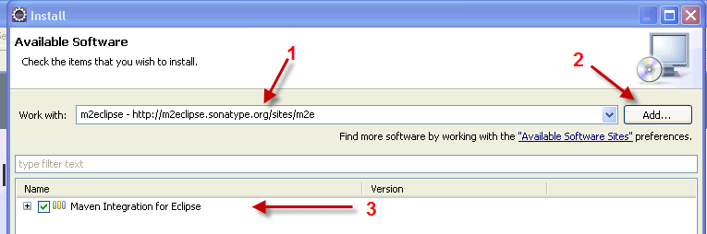

Type just the URL (http://m2eclipse.sonatype.org/sites/m2e) (1), click the Add button (2), type in “m2eclipse” for the name, and hit “okay” for adding the repository. You should then click in the box beside “Maven Integration for Eclipse (3), and click the Next button at the bottom of the Install window.

It will verify your selection (making sure dependencies are present), and then give you a chance to go back to add dependencies, or continue by clicking Next.

Accept the license and click Finish.

Restart Eclipse if prompted.

If you get the following warning, click OK to ignore.

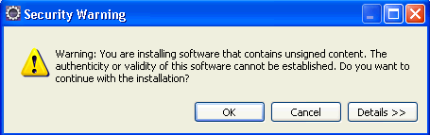

  - Make sure Eclipse is pointed to a JDK rather than a JRE in Eclipse Preferences (Windows → Preferences → Java → Installed JREs and Windows → Preferences → Java → Installed JREs → Execution Environments)
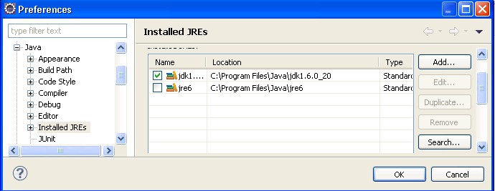

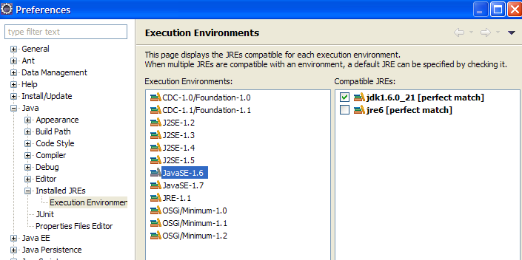
  - Install Subclipse
    - From Eclipse Marketplace: DO NOT DO THIS! It installs correctly, but is missing some important functionality.
    - From Install New Software
      - Select all 3 options from the menu after you enter / select the path as shown below
        - URL = http://subclipse.tigris.org/update_1.6.x
        - Name = anything; suggest “Subclipse”
      - 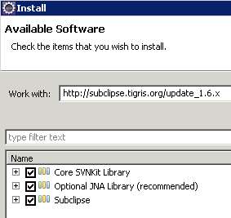
      - Click on Next
        - It will verify your selection (making sure dependencies are present), and then give you a chance to go back to add dependencies, or continue by clicking Next.
      - Accept the license and click Finish
      - If you get the following warning, click OK to ignore.
      - Restart Eclipse if prompted
  - Set Eclipse Preferences for Subversion
    - Window → Preferences → Team → SVN
    - Select a client for the SVN Interface
      - If no clients are listed, you probably installed Subclipse from the Marketplace, and didn’t get the client. Go back to the step about installing Subclipse and get the client.
      - For this example, JavaHL is selected
    - Window → Preferences → Team → SVN → Menu icons
      - Select Tortoise SVN
  - Set up Tomcat Server in Eclipse
    - File → New → Other → Server → Server
      - Select Apache Tomcat 6.0 and use default settings
      - 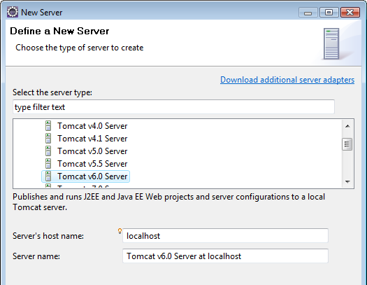

    - Select installation directory, Finish
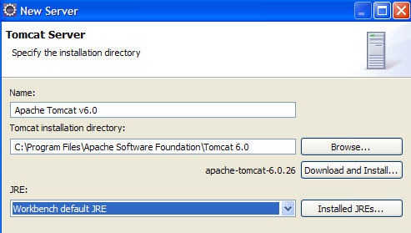

  - Set Eclipse Preferences for Maven
    - Window → Preferences → Maven → Installations → Add → specify Maven root folder (e.g., C:\Program Files\Apache Software Foundation\apache-maven-3.0.3) → OK
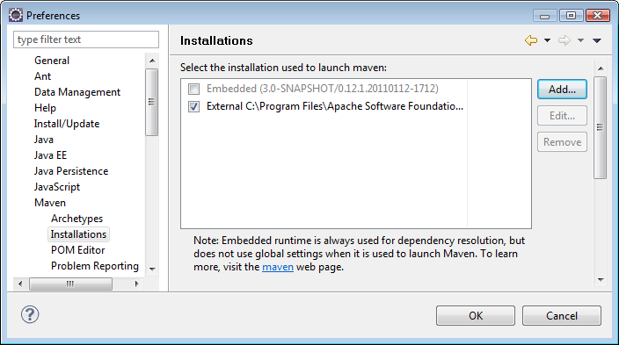
    - Create a settings.xml file in location specified in Eclipse under Window → Preferences → Maven → User Settings

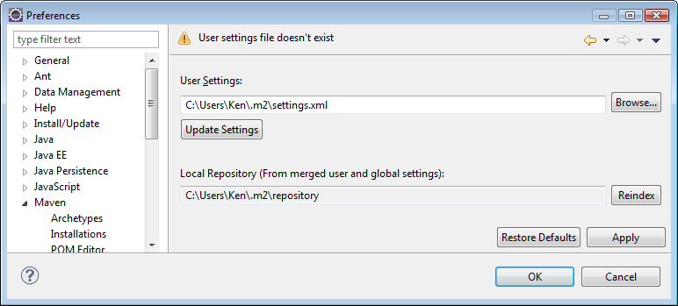

    - Sample XML (used for this example):
<?xml version="1.0" encoding="UTF-8"?>
<settings xmlns="http://maven.apache.org/SETTINGS/1.0.0" xmlns:xsi="http://www.w3.org/2001/XMLSchema-instance" xsi:schemaLocation="http://maven.apache.org/SETTINGS/1.0.0 http://maven.apache.org/xsd/settings-1.0.0.xsd">
<pluginGroups>
</pluginGroups>
<proxies>
</proxies>
<servers>
</servers>
<mirrors>
</mirrors>
<profiles>
</profiles>
</settings>
    - Restart Eclipse
    - Update central Maven repository index, as follows. Note that if you don't do it here, it will automatically take place during the import of Maven projects at step (3) in Section C. We recommend updating the index here, so that if there is an error, it is clear where the error occurred.
      - Windows → Show View → Other → Maven → Maven Repositories
        - Click Global Repositories → right click "central"C:\, select Update Index
        - This may take a while; you can track progress by clicking on the progress icon on the bottom right of the screen ()
        - Sometimes, it takes multiple attempts before this completes. You may need to restart Eclipse in the process.
        - If you see an error message of "Unable to update index for central," it may mean you need to turn off a Proxy connection (see http://www.ehow.com/how_6079770_using-proxy-server.html) or configure Proxy-based Maven connections (see http://maven.apache.org/guides/mini/guide-proxies.html). Once you have made the changes, verify that you do not get this error by repeating the steps above.

  - Install Jboss Drools Eclipse 3.5 Workbench (allows writing Drools rules and working with Drools Flow, and testing / debugging directly from Eclipse). Use either of the following procedures ("automatic installation" option recommended):
    - Manual installation
      - Download the file named Drools Eclipse 3.5 Workbench from http://www.jboss.org/drools/downloads.html
      - Unziip the file into a temporary folder somewhere
      - Copy the contents of the “features” directory to C:\Program Files\eclipse\features
      - Copy the contents of the “plugins” directory to C:\Program Files\eclipse\plugins
      - Restart Eclipse
    - Automatic installation from Eclipse
      - Download Drools plugin for Eclipse
        - Help → Install New Software
        - http://downloads.jboss.com/drools/updatesite3.5/
        - Name used in this example for repository: Drools
        - Install all components

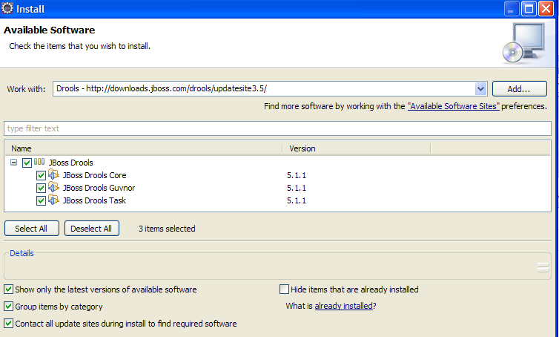

        - If you get the following warning, click OK to ignore.
        - Restart Eclipse if prompted

    - Download the Drools Runtime version 5.1.1
      - Download file named Drools Binaries from http://www.jboss.org/drools/downloads.html, using link at http://download.jboss.org/drools/release/5.1.1.34858.FINAL/drools-5.1.1-bin.zip
      - Unzip the file into a directory (C:\Data\Drools\Drools5.1.1 in this guide)
      - E.g., this directory should look like the following:
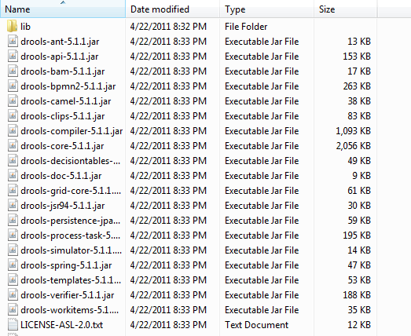

    - Configure Drools Eclipse 3.5 Workbench
Windows → Preferences → Drools → Installed Drools Runtime → Add
        - Add the version of Drools (since you are allowed to have more than one installed) that you want to add to the build path of newly created Drools projects.

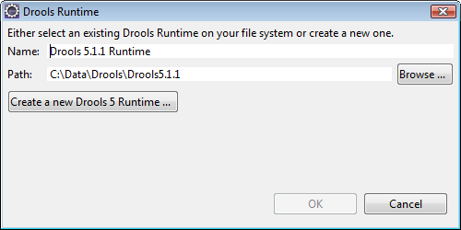

      - Select the Drools runtime for use
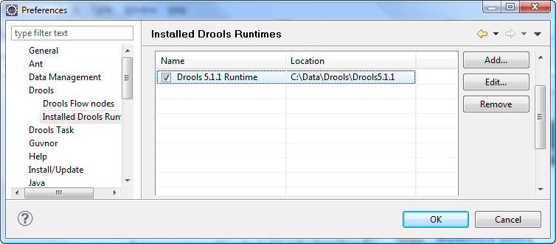

      - Restart Eclipse

OpenCDS Configuration in Eclipse

Both of the projects below (opencds-parent and dss-wsdl-2-java) are imported in the same way. The first one is a Maven parent for all of the dependent OpenCDS Eclipse modules (which are in themselves also projects). These are included within the “opencds-parent” Subversion project as dependent Maven Modules. All of these projects are in Subversion. A detailed walk-through of the opencds-parent project is available in the “Overview of OpenCDS components” document in the Project Documents page of http://members.opencds.org.

- opencds-parent (contains only the POM file for Maven to define all the dependencies for the project, including the following modules)
  - opencds-drools-service (work in progress, adapter with interfaces to DSS Web services and to Drools, packaged as WAR file)
  - opencds-vmr-internal (work in progress, basic Java beans with support for mapping data in from vmr-external, and mapping results out to vmr-external, packaged as JAR file which is used by both opencds-drools-service and by Drools Guvnor for KnowledgeBase authoring)
  - opencds-vmr-external (data classes generated by JAXB from vMR schema, which is included in project, packaged as JAR file)
  - opencds-common (utilities, vocabulary, and simplified datatypes based on ISO 21090 datatypes, found in vmr-external, and mapped in and out of vmr-internal, packaged as JAR file used by both OpenCDS Drools Service and by Drools Guvnor for KnowledgeBase authoring)
  - dss-java-stub (stable, OMG DSS v.1 base code, packaged as JAR file)
  - opencds-terminology-services (base code for use of terminology services)
  - opencds-simple-terminology-service (simple terminology service implemented using XML files, with ability to use Apelon DTS to populate XML files)
  - opencds-apelon (interface to Apleon DTS terminology service)
- dss-wsdl-2-java (closed project – do not build – for archival purposes only)
  - closed project,
  - Is run once when there are changes to the standard DSS WSDL.
  - Flat java package is then manually adjusted to final hierarchical package structure.
  - The final package structure is then manually copied to project dss-java-stub as a dependency for the basic operation of the DSS.
  - WARNING: rebuilding this project will overwrite the existing manually adjusted package structure. You will then need to spend a day or two to rework the package structure to match all the existing dependent code… Do NOT rebuild this project and check it in unless you are prepared to deal with all the downstream consequences.

Download and install Drools 5.1.1 jars into local Maven repository
- Go to http://www.jboss.org/drools/downloads.html
- Download Drools binaries at http://download.jboss.org/drools/release/5.1.1.34858.FINAL/drools-5.1.1-bin.zip (note: if you followed the instructions above, you should already have these files on hand)
- Unzip binary
- Install required Drools binaries into local Maven repository using following script from command line, after updating source path to where the unzipped files are located.
  - Note: you can paste the whole set of commands into the command line at once; they will execute in sequence

mvn install:install-file -Dfile="C:\Data\Drools\Drools5.1.1\drools-api-5.1.1.jar" -DgroupId=org.drools -DartifactId=drools-api -Dversion=5.1.1 -Dpackaging=jar

mvn install:install-file -Dfile="C:\Data\Drools\Drools5.1.1\drools-core-5.1.1.jar" -DgroupId=org.drools -DartifactId=drools-core -Dversion=5.1.1 -Dpackaging=jar

mvn install:install-file -Dfile="C:\Data\Drools\Drools5.1.1\drools-compiler-5.1.1.jar" -DgroupId=org.drools -DartifactId=drools-compiler -Dversion=5.1.1 -Dpackaging=jar

mvn install:install-file -Dfile="C:\Data\Drools\Drools5.1.1\drools-decisiontables-5.1.1.jar" -DgroupId=org.drools -DartifactId=drools-decisiontables -Dversion=5.1.1 -Dpackaging=jar

Download and install Spring Source jar into local Maven Repository
- Go to https://ebr.springsource.com/repository/app/bundle/version/detail?name=com.springsource.org.apache.jasper.springsource&version=6.0.20.S2-r5956
- Download binary at https://ebr.springsource.com/repository/app/bundle/version/download?name=com.springsource.org.apache.jasper.springsource&version=6.0.20.S2-r5956&type=binary

- Install binary into local Maven repository using following script from command line, after updating source path to where the jar is located:

mvn install:install-file -Dfile="C:\Data\Downloads\com.springsource.org.apache.jasper.springsource-6.0.20.S2-r5956.jar" -DgroupId=org.apache.jasper.springsource -DartifactId=com.springsource.org.apache.jasper.org.eclipse.jdt.springsource -Dversion=6.0.20.S2-r5956 -Dpackaging=jar

Apelon Configuration in Eclipse

- These instructions are based on information from http://sourceforge.net/apps/mediawiki/apelon-dts/index.php?title=DTS_3.5_API_Development_with_Maven. Note that most of the configuration has already been taken care of in the POM files of relevant projects.
- Directions below assume using SQL Server 2008 as the backend of Apelon DTS. Use of earlier versions of SQL Server will require additional configuration changes that are not specified here.
  - Download SQL Server 3.0 JDBC from http://www.microsoft.com/downloads/en/details.aspx?FamilyID=a737000d-68d0-4531-b65d-da0f2a735707&displaylang=en
    - In this example, the 1033\sqljdbc_3.0.1301.101_enu.exe file is downloaded, and then executed to unzip the contents into a temporary directory
  - Install sqljdbc4.jar into local Maven repository by executing following from command line, after updating source path to where the unzipped files are located. The sample instruction below uses a source path of “C:\Data\Downloads\SQL Server 2008 JDBC Driver\Microsoft SQL Server JDBC Driver 3.0\sqljdbc_3.0\enu\sqljdbc4.jar” which you should modify to reference the location where you downloaded the driver:

mvn install:install-file -DgroupId=com.microsoft.sqlserver -DartifactId=sqljdbc -Dversion=3.0 -Dpackaging=jar -Dfile="C:\Data\Downloads\SQL Server 2008 JDBC Driver\Microsoft SQL Server JDBC Driver 3.0\sqljdbc_3.0\enu\sqljdbc4.jar"

Import Projects into Eclipse
- Add the OpenCDS repository to the list of repositories available to Eclipse.
  - Window → Show View → Other…→ SVN → SVN Repositories
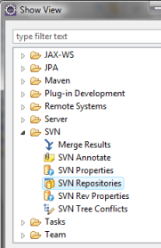
  - You will see a list of the configured Subversion repositories (your initial list may be empty). Right-click on the list and choose New → Repository Location from the pop-up dialog
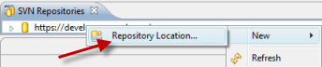
  - Add the repository for the OpenCDS Alpha Project as “http://develop.opencds.org/svn_alpha/trunk/opencds-parent”
And click on Finish
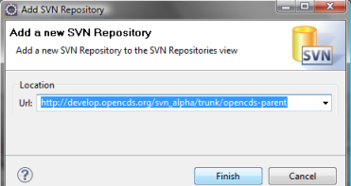

Your SVN Repositories window should now have the OpenCDS Alpha repository available. For downloading the OpenCDS SVN resources, no user ID or password needs to be specified.
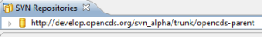

- Import the OpenCDS Project Step 1: Import from the OpenCDS SVN repository in two steps:
  - File → Import → SVN → Check out Projects from SVN
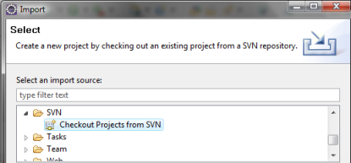

  - Select location of repository as http://develop.opencds.org/svn_alpha/trunk/opencds-parent
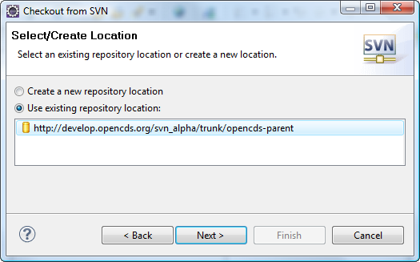

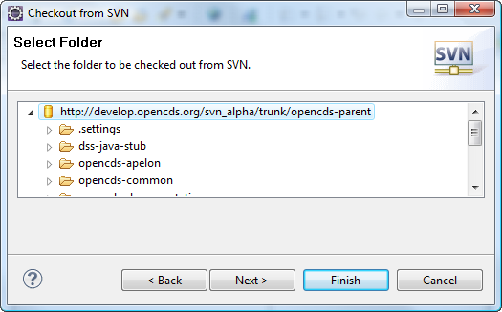

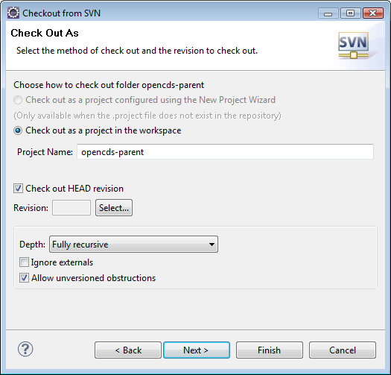

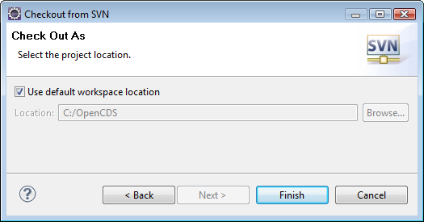

  - The steps above import just the parent project. Eclipse will not recognize that it is a multi-module Maven project, although it will import all the subsidiary modules. You should see something like this:

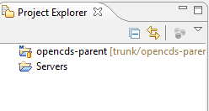

- Import OpenCDS Step 2: Maven import to bring in the OpenCDS Modules:
  - File → Import → Maven → Existing Maven Projects
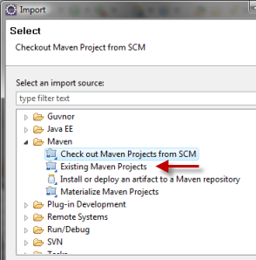

  - Browse to workspace as Root Directory (C:\OpenCDS in this example)
  - All of the subsidiary modules should then appear as separate projects in Eclipse, even though they are nested within opencds-parent on disk.
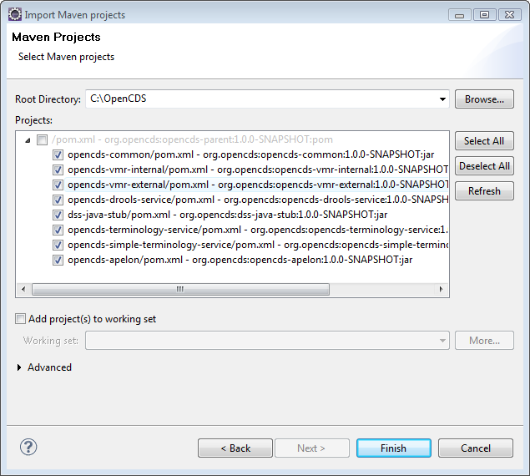

  - Make sure that all of the subsidiary modules are checked, and click Finish. This process may take a while. Clicking on the icon below at the bottom right of Eclipse will show details of the progress.
  - 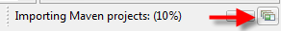
    - Further details can be seen by opening the Console.
    - Sometimes, the Maven-based dependency downloading hangs. If this happens, it seems to happen during the Apelon DTS download (e.g., you may see something like the first line below, but then have no further downloads regardless of how long you wait):
4/25/11 11:25:52 AM EDT: Downloaded http://apelon-dts.svn.sourceforge.net/svnroot/apelon-dts/repos/repo/apelon-dts/common/3.5.0/common-3.5.0.jar

      - If this occurs (no new downloads are occurring after 5+ minutes), attempt to close Eclipse. If Eclipse is unresponsive, kill Eclipse via the Task Manager. Then follow the Troubleshooting instructions below in Section F. This essentially involves deleting out the installation to this point and starting over. There are ways to attempt to recover from later in the install process (e.g., by deleting out the contents of the Maven repository except for the .cache folder, which contains the indexes to the central repository contents). However, unless you feel very comfortable with Maven manipulations, we recommend conducting a clean re-install to make sure that the build is correct.

  - Following a successful Maven import, you will get something that looks like this in Eclipse. Ignore any error icons you may see next to projects for now.
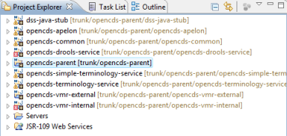

Build OpenCDS Eclipse Project

- Note: depending on the specific version of the various components you have downloaded above, it may take different permutations of the steps below to complete an initial clean build of OpenCDS. Thus, please view the directions below as a sample approach. Once you have an initial clean build, subsequent builds should complete without problems.
- Close and re-open Eclipse
  - Right click on each project other than opencds-parent (e.g., opencds-common)
    - Properties → Java Compiler
    - If “Enable project specific settings” is checked, uncheck it and hit OK
    - If prompted to rebuild project, say No (we will do this all at once shortly)
  - Project → Clean → Clean All Projects → OK
  - Right click on opencds-parent → Refresh
  - Right click on opencds-parent → Run as → Maven Clean
  - Right click on opencds-parent → Run as → Maven Install
  - Right click on opencds-parent → Refresh
  - Restart Eclipse
  - If you see errors in opencds-drools-service related to .drl files, do the following:
    - Window → Open Perspective → Other → Drools
    - You will see an Errors icon; expand it and delete the contents by highlighting them, right clicking, and selecting Delete. These errors are artifacts for properly working Drools DRL files exported from Drools Guvnor.

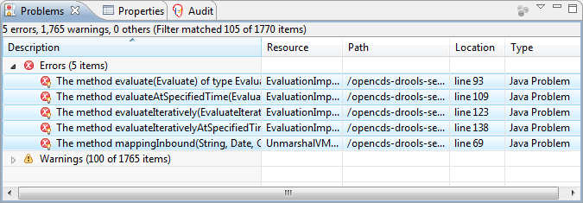

- The jar file created in opencds-drools-service is available in the Binary Downloads section of http://members.opencds.org

Troubleshooting
Maven is great when things are working. However, it can be challenging to get things to work when Maven is not working. The most common problem will look something like this:
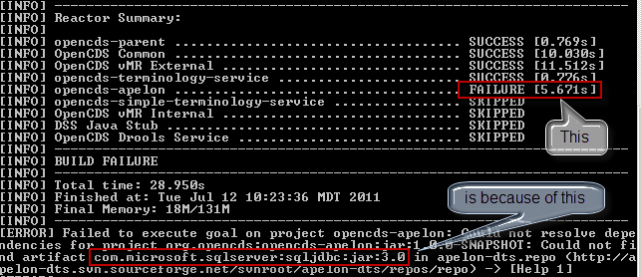

Here are a couple suggestions to fix the problem:

Check the results of the Maven Installs
Maven will sometimes report a successful installation when the specified file (the “-Dfile=…” parameter) does not exist. This will then cause downstream failures of Maven builds. Verify that the local Maven repository contains the jar files you installed by looking in your local Maven repository (found as a folder named “.m2” in your “User” directory). For example, this path for the SpringSource jar will be:
.m2\repository\org\apache\jasper\springsource\com.springsource.org.apache.jasper.org.eclipse.jdt.springsource\6.0.20.S2-r5956\com.springsource.org.apache.jasper.org.eclipse.jdt.springsource-6.0.20.S2-r5956.jar

If you find that one of the jars that you installed with a “mvn install …” command is missing, then rerun the installation, making sure that you have used the correct path for the source file, and spelled everything correctly. The most common error is to download the files to the default download path on your machine (eg, “C:\yourUserName\Downloads”), but to install it using the sample command that we furnished which has a different path. Another common problem is that the downloaded package might have a “.zip” extension, and needs to be changed to a “.jar” extension before use.

The nuclear option
If you cannot get things to work using the above approach (usually due to a Maven issue), you can reset your system to the state just prior to the installation of Eclipse (section F) by doing the following:
- Delete Eclipse folder (e.g., C:\Program Files\eclipse)
- Delete OpenCDS workspace (e.g., C:\OpenCDS)
- Delete Maven repository (e.g., C:\Users\Ken\.m2)

You can then re-attempt the installation and configuration process.

Drools Guvnor Configuration

Option A: download drools-guvnor.zip and e opencds_guvnor_repository_export.xml from Binary Downloads section of http://members.opencds.org and follow instructions on that Web page

Option B: build from source, as below

- Download Drools Guvnor 5.1.1 war file from JBoss
  - Download from http://download.jboss.org/drools/release/5.1.1.34858.FINAL/drools-5.1.1-guvnor.war
    - note: a version with the JBoss App Server is also available at http://download.jboss.org/drools/release/5.1.1.34858.FINAL/drools-5.1.1-guvnor-standalone.zip. However, since we will be using Tomcat, you do not need to download this version.
  - Rename war file as drools-guvnor.war
  - Place war file in Tomcat webapps directory (e.g., C:\Program Files\Apache Software Foundation\Tomcat 6.0\webapps)
  - Start Tomcat (e.g., through Control Panel → Administrative Tools → Services)
  - Once the .war file has been exploded into a drools-guvnor folder, go to its lib directory (e.g., C:\Program Files\Apache Software Foundation\Tomcat 6.0\webapps\drools-guvnor\WEB-INF\lib) and add the following OpenCDS jars, which can be found in the target folders of the relevant OpenCDS project folder following the build process described in the previous section (e.g., at C:\OpenCDS\opencds-parent\opencds-common\target)
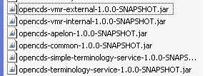

  - Restart Tomcat

- Verify installation
  - Go to http://localhost:8080/drools-guvnor/org.drools.guvnor.Guvnor/Guvnor.html
  - Login as any user name, blank password
  - Select “No thanks” if prompted to install a sample repository
  - Upload latest OpenCDS implementation via Administration → Import/Export. ID and password can be left blank if prompted. The latest opencds_guvnor_repository_export.xml Guvnor repository file is available from the Binary Downloads section of http://members.opencds.org

